Web Design Capstone

I am Akash Ambashankar and my submission for the Web Design for Everybody Specialization Capstone is a website to track the Coronavirus Pandemic and its spread in India and across the world.

Some of the components in my website are:

1. Bootstrap based layout
2. Header with Bootstrap navigation
3. Live updates on the Coronavirus Pandemic under various categories
4. Graphs and charts regarding the spread of the pandemic
5. Link to donation for relief funds

All the components have been styles using CSS while keeping accessibility in mind. Certain interactive features have been included using JS.

Validation

According to the [w3 validator](https://validator.w3.org/), my website does not have any errors or warnings.

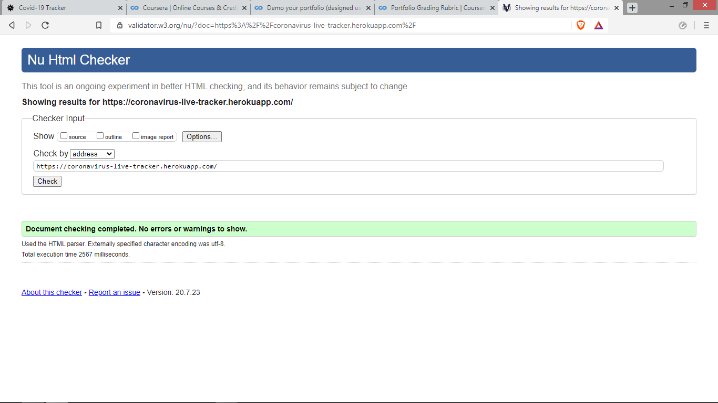

Responsiveness

The website is designed to have two major views; one for large screens and the other for mobile devices.

Large Screen view:

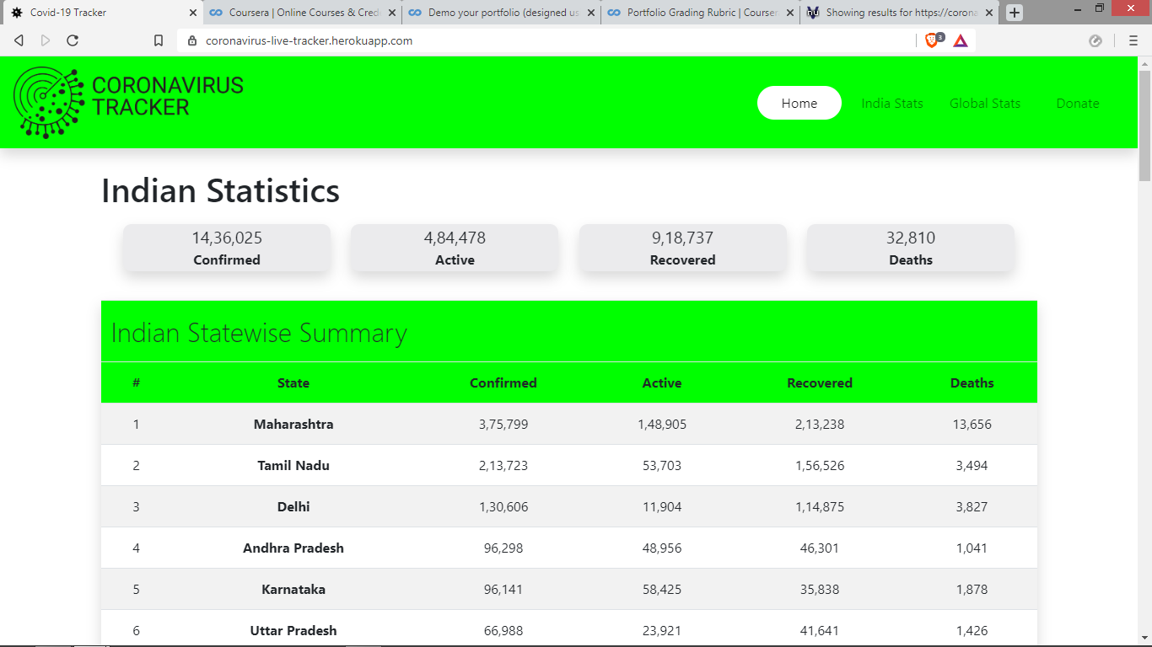

Mobile view:

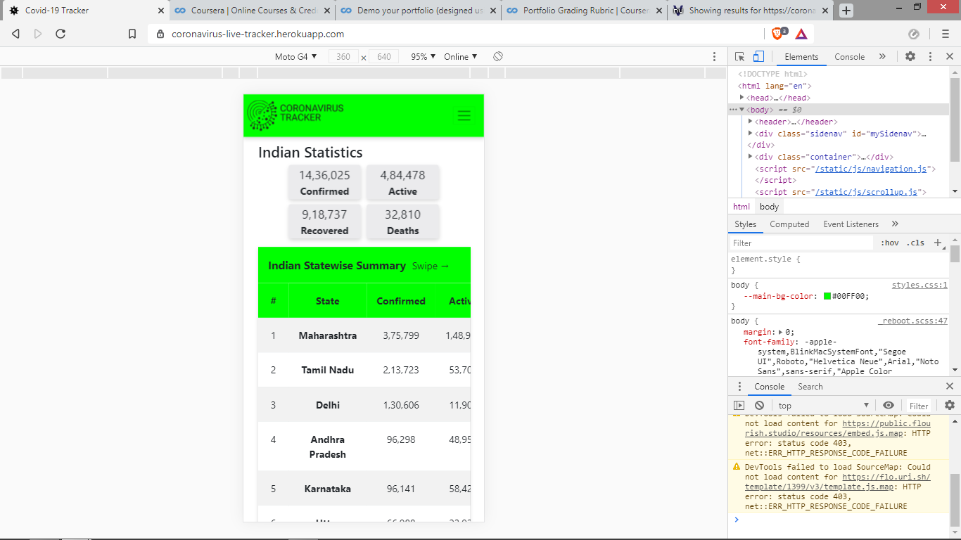

Styling

The website is styled with a green theme and has the following styling:

1. Hover effects
2. Collapsible navigation
3. Responsive tables
4. Box shadows

And more.

Enhancements

Beyond the content taught in the course, the website has the following enhancements:

1. Use of the Python module Flask to enable server side programming
2. Use of APIs to provide live updates
3. Use of iframes to provide charts and graphs
4. Use of various icons from Font Awesome
5. Implementation of Bootstrap Carousel
6. Implementation of Sticky Footer
7. Mobile friendly responsive navigation bar
8. Mobile friendly responsive tables

Thank you for taking the time to review my website. You can visit the website at coronavirus-live-tracker.herokuapp.com.